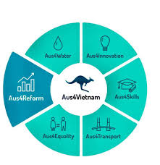
AGENDA
ANNOUNCEMENT WORKSHOP
The Report on The Launching workshop of Report on The implementation of Government’s Resolution No.02/2019
and No.35/2016 – A view from business
VCCI, Hanoi, 17 December 2019
08:00 - 08:30 | Registration
08:30 - 08:50 | Welcome Remarks  Dr. Vu Tien Loc, VCCI President and Chairman
08:50 - 09:40 | Report summary  - Overview of the research  - Results, best practices and recommendations  Mr. Dau Anh Tuan, Director of Legal Department, VCCI
09:40 - 10:00 | Discussion  Participants from State agencies, business associations and experts
10:00 – 10:15 | Coffee break
10:15 – 11:15 | Discussion  Participants from State agencies, business associations and experts
11:15 – 11:30 | Closing remarks
11:30 | Lunch

