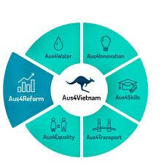
AGENDA
LAUNCHING WORKSHOP OF REPORT ON DOING BUSINESS IN VIETNAM: EVALUATION OF WOMEN-OWNED BUSINESSES
VCCI, Hanoi, 19th December 2019
08:00 - 08:30 | Registration
08:30 - 09:00 | Welcome Remarks  - Dr. Vu Tien Loc, VCCI President and Chairman  - Ms. Le Thi Nguyet - Vice President of National Assembly's Committee on Social Affairs  - Ms. Kellie Raab – Acting Economic and Development Cooperation Counsellor of Australian Embassy
09:00 - 09:30 | Report summary  - Overview of the research  - Results, best practices and recommendations  Mr. Dau Anh Tuan, Director of Legal Department, VCCI, Director of the Program “Enhancing business participation in monitoring and implementation of economic restructuring”
09:30 - 10:00 | Discussion  - Comments from enterprises and business associations;  - Comments from State agencies  - Comments from experts;  - Comments from other participants
10:00 – 10:15 | Coffee break
10:15 – 11:15 | Discussion  - Comments from State agencies;  - Comments from women-owned businesses and organisations for supporting womens’ startups and entrepreneurship;  - Comments from other participants
11:15 – 11:30 | Closing remarks
11:30 | Lunch

